Task 1
Recreate the following lists using HTML and css. You will need to use CSS to change the list-style property. This allows you to format the bullets as they appear in the picture.
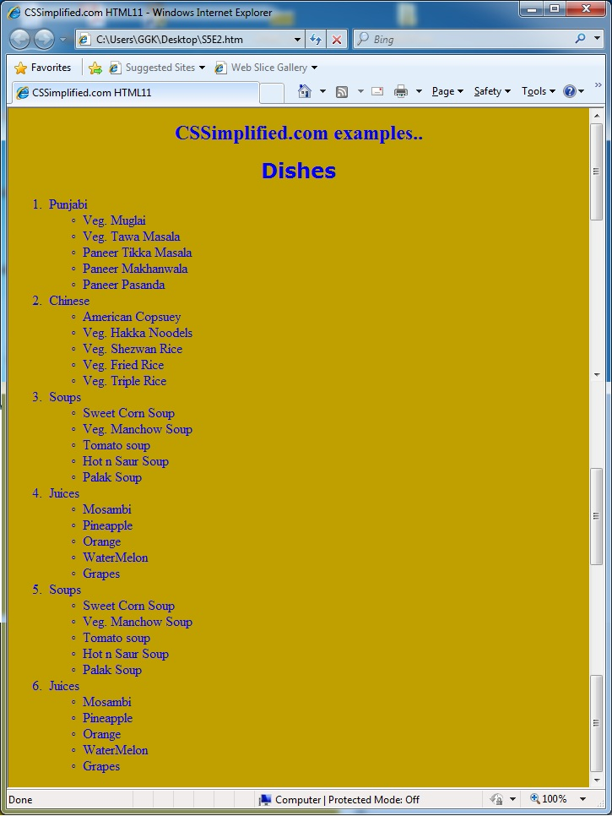

Task 2
Now, create a nested list. You can give use IDs in any way that you see fit.
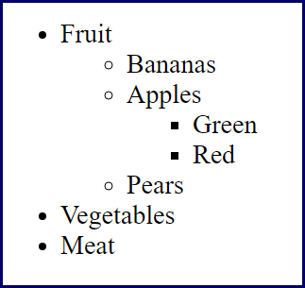

Task 3
Recreate the following page using your knowledge of basic HTML and CSS
